## **EXPERIMENT NO. 9**

**Aim:** Analyze competitor activities using social media data.

**Theory:**

**What is a Competitor Analysis?**

A competitor analysis, also referred to as a competitive analysis, involves identifying competitors in your industry and researching their marketing strategies. This analysis helps to compare your company’s strengths and weaknesses with competitors to gain a competitive edge.

**Why Conduct a Competitor Analysis?**

1. **Identify Strengths and Weaknesses:**
   * Understand how competitors are perceived in the market.
   * Identify areas where your business excels or falls short.
2. **Understand Your Market:**
   * Discover new or overlooked competitors.
   * Identify gaps in the market to address unmet customer needs.
3. **Spot Industry Trends:**
   * Monitor trends without blindly imitating competitors.
   * Focus on creating unique value for customers.
4. **Set Benchmarks for Growth:**
   * Study larger, established companies as models of success.
   * Analyze new entrants for potential threats.

**When Should You Conduct a Competitor Analysis?**

* While starting a new business.
* Periodically, to identify trends and maintain a competitive edge.

**Steps to Conduct Competitor Analysis:**

1. **Identify Competitors:**
   * Classify competitors as direct, indirect, or replacement competitors.
2. **Create a Competitor Matrix:**
   * Organize data in a structured table or spreadsheet.
3. **Gather Background Information:**
   * Study company history, size, location, and target customers.
4. **Profile Competitors’ Target Customers:**
   * Understand competitors' customer demographics and preferences.
5. **Focus on the 4 P’s:**
   * Product: Analyze features, strengths, and weaknesses.
   * Price: Compare pricing models and affordability.
   * Promotion: Study advertising channels and messaging.
   * Place: Identify sales channels and distribution methods.
6. **Analyze Strengths and Weaknesses:**
   * Evaluate competitors’ and your own business performance to refine strategies.

**Competitor Analysis Tools Used:**

**1. Using Google Trends:**

* Compare the search popularity of ChatGPT, ChatSonic, and Google Bard.

**Step 1:** Go to [Google Trends](https://trends.google.com/trends/) and sign in with your google account. Add any software you want to compare.

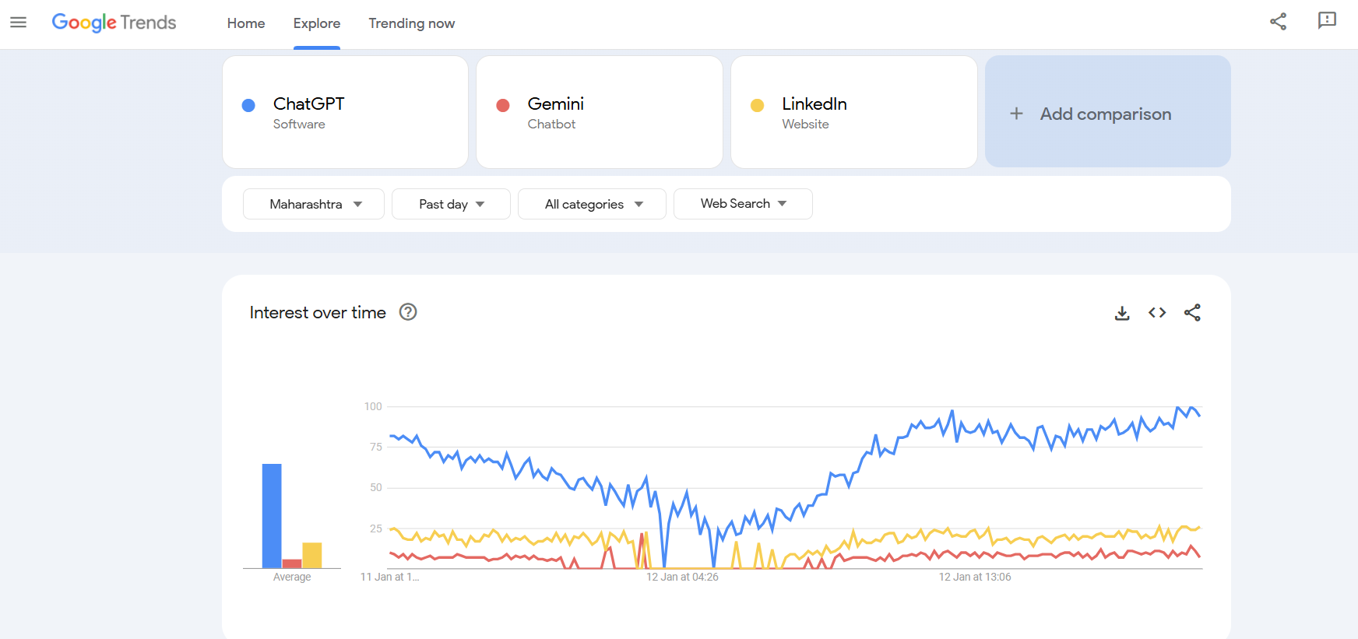

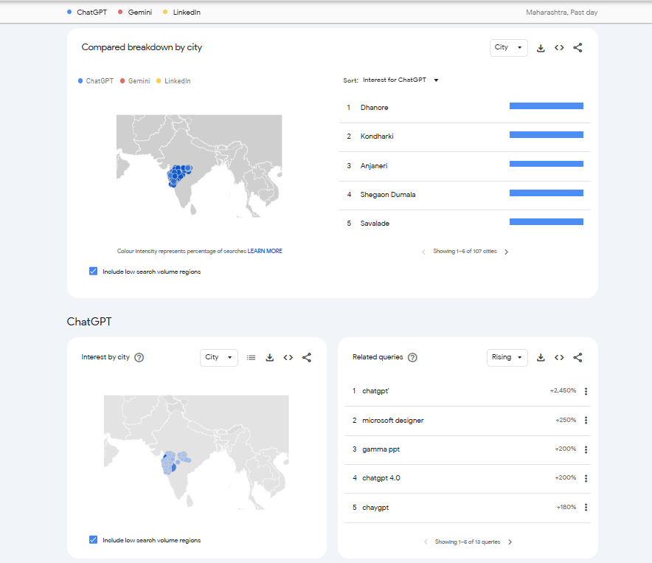

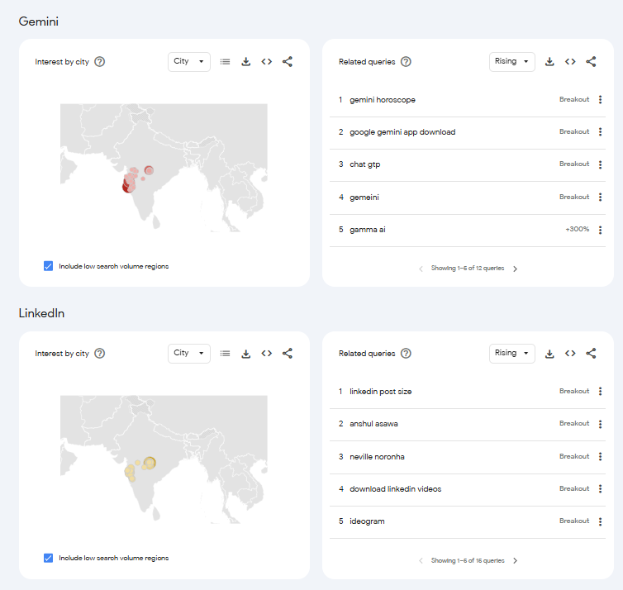

**2. Using Similar Web:**

* Analyze website traffic, audience demographics, and engagement metrics.

Step 1: Go to [Similarweb](https://www.similarweb.com/) and login with your google account. Select Website Analysis and add websites you want to compare.

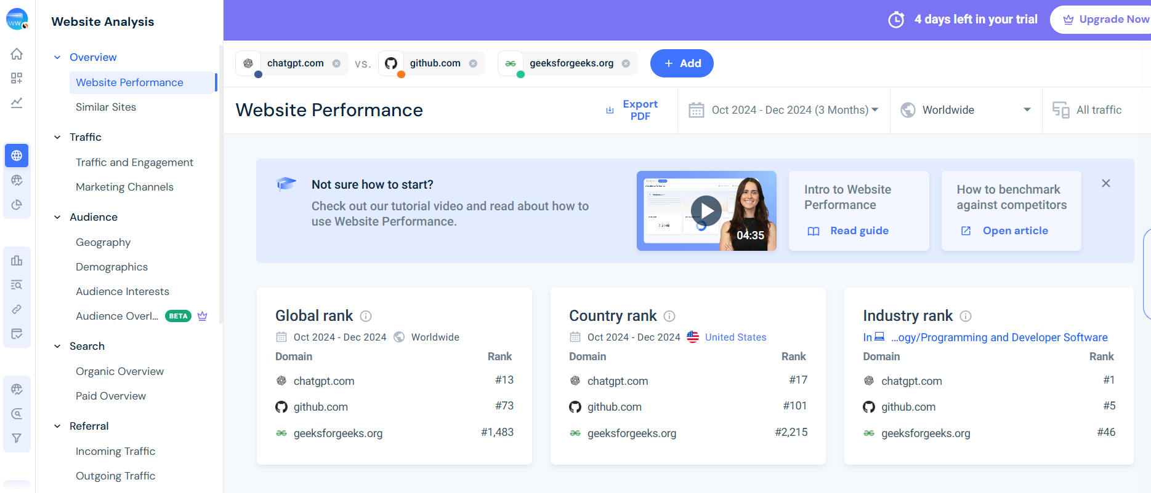

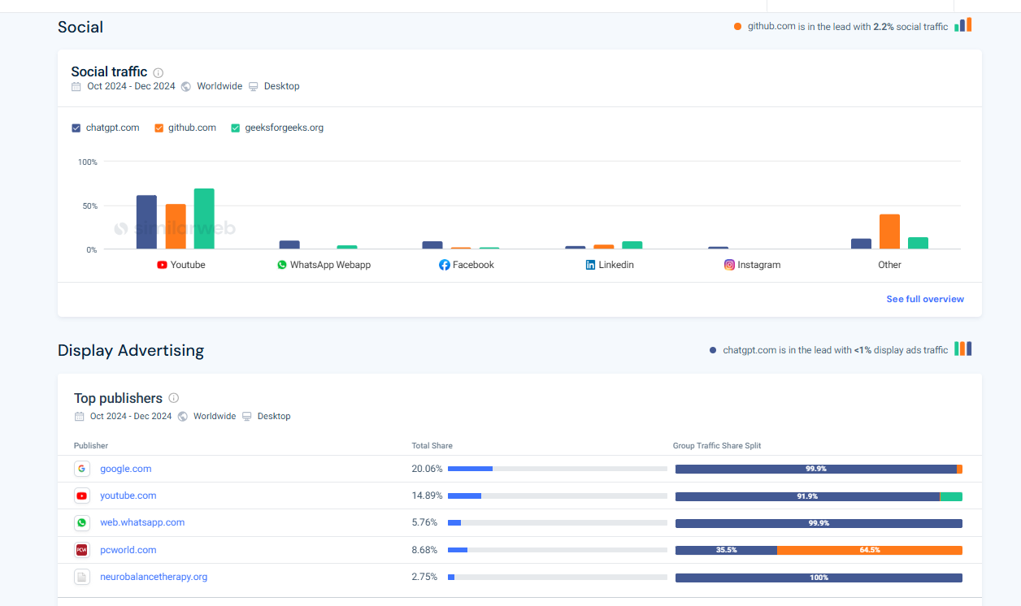

**Conclusion:**

Thus, the competitor analysis is done using 2 different ways and understood how to perform competitor analysis in different forms.